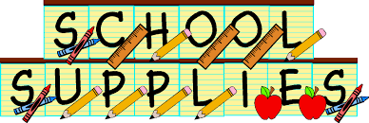

2nd Grade Supply List for 2019-2020 School Year
2 - Boxes of twelve #2 Pencils
3- Reams of White Copy Paper
4 - Boxes of Tissues
2 - 4 pack of Expo Markers (4 or more per package. Not Crayola)
2 - Clorox Wipes
2 - Rolls of Paper Towels
1 - iPad (optional)
1 - Headphones
1- Set of Markers (broad tip, min of 10 colors)
2- Pink Erasers
1 - Container of Expo Wipes
3 - Glue Sticks
1 - 24 pack of crayons
1 - Set of colored Pencils
1 - Standard Backpack (please no roller backpacks)

FOR ART:
Antibacterial Wipes
Paper Towels
Kleenex
Please provide the following in a Pencil box:
Set of 24 Crayola Crayons
Set of Crayola Markers, both Think and Thin (student choice of quantity)
Pencils
EPentel Hi-Polymer Latex Free Block Eraser, White, 3/Pack (Staples)
Chalk Pastels (Artist Loft at Michael’s is the cheapest/sets for 5.99)

